Clever Login Instructions
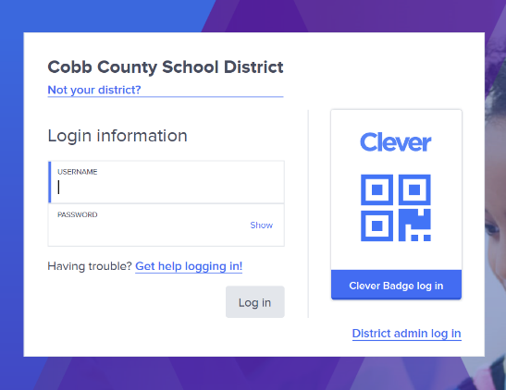

Step 1: Go to www.clever.com

Step 2: Click Log in as student then log in with clever

Step 3: Click log in with clever

Step 4: Enter your login credentials
Username: Your student ID (lunch number)
Password: Your student ID (lunch number)

Step 5: You will be prompted to change your user name and password. DO NOT change it. Enter the student ID (lunch number) again for both the user name and password.

* Once logged in students can access:
Dreambox (Math practice)
Freckle (All subjects)
Learning A-Z (Reading)
X-tra Math (fact fluency)
Typing club (Typing practice)
And More!

Education Galaxy Login Instructions

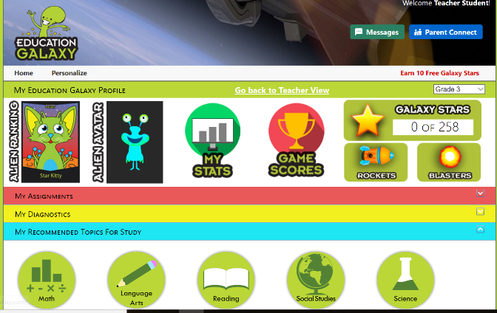
Step 1: Go to www.educationgalaxy.com

Step 2: Enter log in information
Username: Student ID
Password: Student ID

Once logged in, students can practice any subject

